**Exercise No: 7**

**Date: 23-11-2020**

________________________________________________________________________________

**AIM:** To perform various operations on lists.

**LINK**:

<http://103.53.53.18/mod/hvp/view.php?id=316>

**

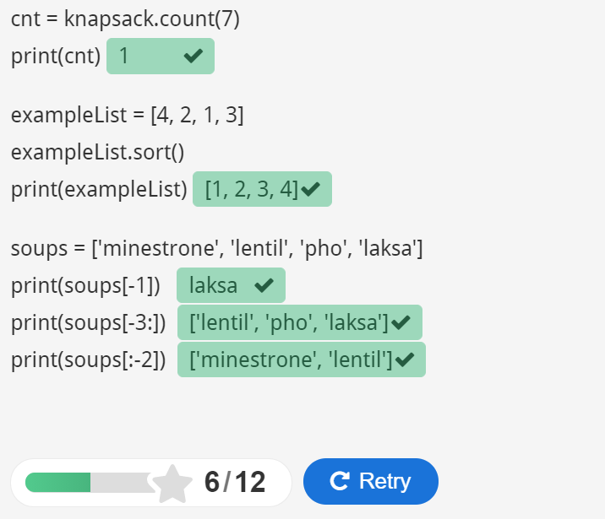

**RESULT:** Thus, various operations on lists are executed.